**OFFICIAL COORDINATION REQUEST FOR**

**NON-ROUTINE OPERATIONS AND MAINTENANCE**

**COORDINATION TITLE- Updated 16BON11** NDE Lamprey Flume Improvements/ Repairs

**COORDINATION DATE-** 20 April 2016

**PROJECT-** Bonneville Lock and Dam – Washington Shore Fish Ladder

**RESPONSE DATE-** 09 June 2016

**Description of the problem** – In 2012-2013 the U.S. Army Corps of Engineers (USACE/Corps) installed a prototype adult Pacific lamprey flume structure designed to improve lamprey passage at the Bonneville WA Shore Fish Ladder, near the north downstream entrance (NDE). The water velocities in the upper portion of the lamprey flume system (LFS) are high under certain tailwater (TW) elevations. A velocity barrier plate will be installed within the LFS to provide a lower velocity passage route through the flume. Additionally, an access hatch located in the upper portion of the LFS below the water line (TW > 8 ft.) was damaged and torn off in 2015. The LFS repairs are part of a larger contract that includes minor modifications in the WA shore fish ladder (e.g., rest boxes and orifice transition plates) and the installation of a new lamprey passage structure near the fish ladder exit in the forebay. The Corps intends to repair the hatch and install the velocity barrier plate in mid to late November 2016. The contractor must use divers to assist in the installation of the velocity barrier plate and replace the missing hatch (may require removal and replacement of damaged hinges). Work on the LFS will occur within the boat restricted zone of the tailrace and is anticipated to require 2 to 5 days of dive operations. Dive safety requires a near 0 flow work environment for divers.

This work is being completed to fulfill our commitments under the current fish accords. It is important to complete this work in a timely manner to facilitate the in water seasoning (1 to 2 years) of the lamprey flume system so that it can be adequately evaluated prior to the end of the fish accords in FY 18.

**Type of outage required- 21 to 24 November 2016**

* Powerhouse 2 (PH2), units 11-18, will be out of service for transformer 11 (T11) and transformer 12 (T12) commissioning 21 to 24 November 2016 (the final schedule is TBD based on regional coordination of MOC 16BON14).
* PH1 will be the priority powerhouse when the T11/T12 outage occurs through the CY 16/17 IWWW.
* The fish units will also be OOS during the T11 and T12 outage.
* The PH2 Downstream Migrant Channel (DSM) will be dewatered during the entire dive operations work window. The DSM outflows create upwelling conditions that negatively impact dive operations. The DSM will be returned to service after the dive work is completed.
* B2CC will be opened to provide a surface route for downstream migrating fish.
* Spill bays 1 and/or 18 will be operated for adult attraction. Spill is only required from the bay(s) adjacent to an operating fishway entrance (1 stop per bay) per the FPP.
* Anticipated work may include use of a floating plant at the north end of PH2 and a crane on the tailrace deck. A safety boat will be required in the BRZ near dive operations.

**Impact on facility operation-**

Chum operations will be in effect during the scheduled outage and are anticipated to be set at a TW elevation of 12.2ft. This will require approximately 100,000 – 140,500 cfs to be passed through BON, depending on tidal conditions and Willamette River flows. Assuming water inflows will exceed PH1 capacity then additional water (see Table 1) required to maintain chum TW elevations will need to be passed over the spillway to supplement BON miscellaneous flows (e.g., ITS PH1, B2CC, and other fish ladders).

In anticipation of the dive work project personal will need to dewater the DSM prior to diving and consider the lead time required.

**Dates of impacts/repairs-**

The T11 and T12 outage will occur from 14 November to 24 November 2016. However the dive work will occur for a 2 to 5 day period during the T11/T12 (MOC 16BON14) outage window.

**Length of time for repairs-** 2 to 5 days

**Expected impacts on fish passage-**

This outage for dive work is proposed during the FY16 T11/T12 (MOC 16BON14) outage and does not cause major additional impacts to fish. The DSM2 outage is in addition to the PH2 outage and will have some impacts on fish, if present in the forebay. To mitigate impacts and provide a surface passage route the B2CC will be in operation.

*Downstream migrants (including adult fallback and kelts)*

The operation coincides with the ascension of the winter steelhead run; the daily average steelhead count during the proposed outage is 87 per day (range 62 to 109; includes adipose clipped and non-clipped steelhead; DART; figure 1 and 2). PH1 will be priority during this outage and therefore most of the attraction flow will be from the Oregon shore. The B2CC will provide a surface route for any adult (kelts and overshoots) and juvenile fish present. Juvenile salmonids (specifically age 0 Chinook salmon) are present in low numbers (fish are not counted after 31 OCT; DART, figure 3) at BON dam during the proposed dive work window. However juveniles that are present at BON PH2 will be able to pass via the B2CC. Juvenile lamprey are present in low numbers, if at all during this time frame (figure 3).

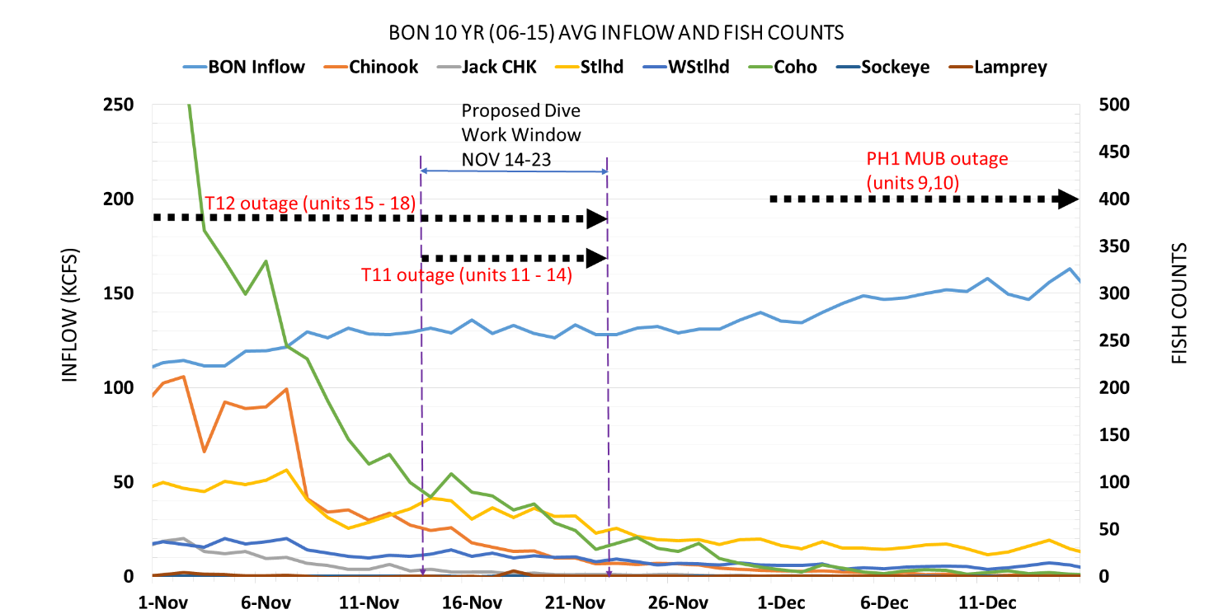

**Figure 1.** BON 10 year average inflows for 2006 - 2015 are shown. Also the 10 year average adult per day fish counts are shown in relation to our proposed dive work windows. The large black arrows show the timing of the scheduled outages at BON during NOV and DEC 2016 that impact the LFS repairs.



**Figure 2.** A bar graph showing the same data for adipose clipped (“hatchery”) and non-clipped (“wild”) steelhead as figure 1. The graph shows the average daily counts of steelhead more clearly than the above figure.



**Figure 3.** 5 year average juvenile fish counts at BON dam from 2011-2015. Fish counts are discontinued the end of October and therefore numbers are unknown.

*Upstream migrants (including bull trout)*

Adult upstream migrants may be delayed at BON PH2 however Cascades Island (including the exit) and Bradford Island will be operating within FPP criteria. In addition most of the attraction flow will be from PH1 so delay should be minimized. Fish that are delayed are at increased risk of predation from pinnipeds (Figure 4; USACE, 2015).



**Figure 4.** Monthly mean Steller sea lion abundance from August through December, 2011-2015. Data was not collected in 2011 and 2012 for August and September. Information from; USACE Fish Field Unit. 2015 Field Report: Evaluation of Pinniped Predation on Adult Salmonids and Other Fish in the Bonneville Dam Tailrace. 2016.

Bull trout, if present, will be impacted the same as upstream migrating steelhead. WDFW and Corps personnel provided a list of anecdotal sightings/captures of bull trout in the mainstem Columbia River. From 2000 through 2012 there were eleven bull trout reported. Three were downstream of Bonneville Dam, with two at the mouth of Hamilton Creek (RM 143) and one in 2005 at the Bonneville Dam Smolt Monitoring Facility (RM 144). Upstream of the dam, one bull trout was found at Cascade Locks (RM 149), two at Drano Lake (RM 162), two at the mouth of the Klickatat River (RM 180.5), one in 2002 at the John Day Dam Smolt Monitoring Facility (RM 215), and one sighting at Dog Creek Falls by a reputable WDFW creel sampler who observed 18 to 24-inch cuts or dollies working old redds below the splash pool over the course of two weeks.

Fish passage data from the Bonneville Dam fish ladders (Corps, unpublished) show only three sightings of bull trout moving through the fish ladders for 2000 through 2011 during the fish counting season (1 APR through 31 OCT). These sightings occurred between 30 MAY 2009 and 2 JUN 2009 and were reported as “12-inch bull trout moving upstream” through the count window on each occasion.

Few adult Pacific lamprey are present if at all during this period and therefore are not a concern (figure 1).

TDG may be a concern for chum eggs and adult fish if the spill cap is reached, at 70 Kcfs resulting in ~110% TDG. Depending on the depth of chum redds, egg exposure to TDG will be lower due to depth compensation.

Table 1. Spill scenarios depending on seasonal inflows at BON dam assuming a complete and partial outage of BON PH2 during 14 NOV to 5 DEC. The spill cap is 70 Kcfs, resulting in ~110% TDG. Chum operations will require a min outflow of 100 to 140 Kcfs to maintain a min 12.2 ft TW elevation depending on Willamette River flows and tidal influence. The numbers presented are conservative for planning purposes.



**Comments from agencies**

**16BON11** MOC LFS DIVE agency: Walker reported that this is about the work that is happening on the LFS on the WA shore. This requires divers in the water and dive safety requires near zero flow at the work site. With the required total PH outage it makes sense to do the dive work when the outage occurs. They are requesting to take the DSM out during this time as well. The outage will happen when T11 / T12 are out which is around Thanksgiving week in November. Mackey said that BPA would probably let us just switch PH priority to PH1 for the remainder of the fish passage season through the whole winter maintenance period. ACTION: Walker to update MOC

**Final results**

Please email or call with questions or concerns.

Thank you,

Ricardo

Ricardo Walker

Fish Passage Section

Environmental Resources Branch

USACE Portland District

Ricardo.Walker@usace.army.mil

Office: 503.808.4709